A Touching Tibetan Character String Database for to Evaluate the Segmentation Algorithm
First Author¹[0000-1111-2222-3333] and Second Author²[1111-2222-3333-4444]
¹ Princeton University, Princeton NJ 08544, USA
² Springer Heidelberg, Tiergartenstr. 17, 69121 Heidelberg, Germany
lncs@springer.com
Abstract. The benchmarking database plays an essential role in evaluating the performance of touching character string segmentation algorithm. In this paper, we describe a database about touching Tibetan character string. We extract authentic raw data from Historical Tibetan documents and filter them. The database we have established can be used to evaluate segmentation algorithms for Touching Tibetan character string. It contains 5,448 two-character and 1,399 more than two-character touching character string. Because of the habit of personal writing and the diffusion of ink, there is a large number of strokes broken in the database. We have annotated ground truth file for each image, which includes class, candidate segment points, baseline and average stroke width of Tibetan single character. According to the location of adhesion, we have divided the touching character string into six types. We counted all the data and found that 76.27% of the data was below the baseline. In the end, we measure the segmentation performance of a foreground-based combined algorithm on this database for reference.
Keywords: Benchmarking Database, Touching Character, Segmentation.
- Introduction
Digitalization of historical documents can protect literature and improve reading efficiency. Through an optical character recognition (OCR) system, we can get the content of the literature. OCR system generally includes image preprocessing, character segmentation and character recognition. The research on the segmentation of the touching character string plays an essential role in character segmentation. It is a traditional but not yet fully solved problem, and related researches have been started since the 1980s [1]. At present, the segmentation about touching character strings (usually digital, letters and Chinese character) has achieved satisfactory results, which has important applications in ZIP code recognition, bank check reading and text recognition. In this field, few scholars pay attention to Touching Tibetan character string.
Most of the time, researchers use different dataset to verify the new algorithm. Finally, the algorithm proposed by researchers can display good performance in their dataset. It is not accurate to evaluate the performance of different algorithms on different datasets. To compare the efficiency and performance of different algorithms and avoid the impact of different databases, some scholars have established the touching character string benchmarking database. Handwritten touching digital database(HWD-TD) [2] and offline Chinese touching character string database (CASIA-HWDB-T) [3] are representative. HWD-TD contains several different kinds of touching and it was generated by connecting 2,000 images of isolated digits extracted from the NIST SD19. Considering the authenticity of artificial synthesis touching character strings, [3] extracted touching character string from CASIA-HWDB and formed a new database. CASIA-HWDB-T contains 56,469 touching character string, most of which are single-touch character, and the 1,818 are multi-touch character.
Inspired by the work of [2] and [3], we established a touching Tibetan character string(TH-TCS), which generated from Tibetan historical document named ‘The complete works of Panchen Lama’. TH-TCS was built by Connected Component Analysis, which was composed of 5,844 images of two-touching character string and 1,399 images of three-touching character string. A foreground-based combined algorithm has been carried out on our database. In the following chapter, we will introduce our database in detail.
- Database
To the best of our knowledge, no database about Tibetan handwritten touching character string have been built so far. Next, we will introduce the collection and annotation information of the database.
  - Data collection
The Tibetan language is usually centered on a single character. The rest characters are written on the top, bottom, left and right sides of the basic character, and all character merge into a complete word. A Tibetan word can be made up of 6 consonant letters. When segmented and recognized Tibetan characters, we usually use the vertical unit as a basic element. We scanned the Historical Tibetan documents named ‘The complete works of Panchen Lama’ and obtained the original scanned images, as shown in Fig. 1. We can see that there are a lot of touching character string in the scanned image, we need to extract and segment it. In the touching character string extraction, we first manually segment the image into row images; Then binarize row images and reduce noise point. In the binarization process, we mark the foreground pixel to 0 and the background pixel is 1. Due to the cause of the ink diffusion and illumination, we deleted the outliers with pixels less than 30 in foreground pixels; At last we collected the original dataset through Connected Component Analysis.
In the Connected component analysis, considering the overlapping of vowels and stroke break, we combined the algorithm proposed by [4] to merge the component. The four nearest neighbor pixels were used to mark row images, and we save the borders and pixels of each connected area. We can mark the four ends of the boundary as $x^{l}$, $x^{r}$, $y^{t}$, $y^{b}$ respectively. We can assume that the boundary information of two connected regions are ($x_{1}^{l}$, $x_{1}^{r}$, $y_{1}^{t}$, $y_{1}^{b}$) and ($x_{2}^{l}$, $x_{2}^{r}$, $y_{2}^{t}$, $y_{2}^{b}$), where $x_{1}^{l}$ less than $x_{2}^{l}$. According to the formula (1), (2) and (3), we can calculate $ovlp$, $span$ and $dist$. $ovlp$ represents the length of the overlapping of two components. $span$ represents the total length of the two components. $dist$ represents the distance of the centroid of the two components.
$ovlp= x_{1}^{l}- x_{2}^{l}$ (1)
$span=\max\left(x_{1}^{r},x_{2}^{r}\right)- x_{1}^{l}$ (2)
$dist= \frac{1}{2}|\left(x_{2}^{l} + x_{2}^{r} \right)-\left(x_{1}^{l} + x_{1}^{r} \right)|$ (3)
Whether the two connected components are merged by $nmovlp$ metric, where W1 and W2 denote the width of two connected components, respectively.
$nmovlp = \frac{1}{2}\left(\frac{ovlp}{w1} + \frac{ovlp}{w2}\right)- \frac{dist}{span}$ (4)
If $nmovlp$ > 0, it means that two connected components can be merged. After the whole row images processing is completed, the ratio ($L_{r}$) of the length to width of the average character is calculated. If $L_{r}$ > 1.3, it is initially determined to be touching character string. After further screening, we removed the single character, overlapping character and error character, and determined the final dataset. Fig. 2 shows the touching character string extracted from row images. In the following, we will introduce the ground truth file’s format for each touching character string

Fig. 1. Example of a page of Tibetan historical documents and some touching character string.
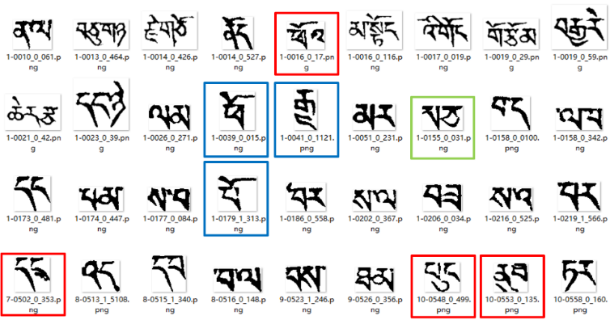
Fig. 2. Some images extracted from Tibetan history document, which contains incorrect image. Overlapping characters are marked with red rectangles, the single character is marked by a blue rectangle and error character is marked by in a green rectangle.
  - Data annotation
All the characters and punctuation in Tibetan language are aligned according to the baseline [5]. This feature is helpful for the segmentation and recognition of Tibetan character. In the segmentation of handwritten digits or Chinese characters, the type of touching will be further classified. And we divided the touch type into 6 categories based on the baseline position and touch style, as shown in Table 1. Through our observation, most of the images in the database are two touching character string. We partition TH-TCS into two sub databases according to the number of character in touching character string: TH-TCS-T and TH-TCS-M. Each image in TH-TCS-T contains two characters and another one is composed of more than two characters, as depicted in Fig. 3 (a) and (b).
Table 1. Touching type of single-touching Tibetan character pair.
Position | Touching Stroke Relation | Examples | Rate (%)
Above the Baseline |  |  | 1.37
On Baseline |  |  | 22.36
Below Baseline | 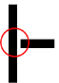 | 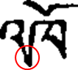 | 76.27


(a)

(b)
Fig. 3. Examples of touching character string samples extracted from the database: (a) each image contains two characters and; (b) each image contains more two characters.
To accurately evaluate the efficiency of the segmentation algorithm, we have annotated the touching character string. The information of the ground truth includes the baseline (BL), the class label (CL), the height and width of image, the average stroke width (SW), and the coordinate of the candidate segmentation point. BL is an important parameter. The vowels are located above the BL, and other characters are under the BL. Using BL to divide the touching characters into two parts can help to improve the accuracy of segmentation. SW and CL are used to evaluate the accuracy of segmentation and recognition respectively. We saved the annotation information in an XML file with the same name as the original image. Fig. 4 depicts an example of an XML file for a touching character strings.
 | 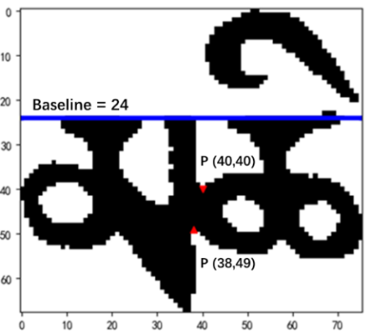
(a) | (b)
Fig. 4. Example of (a) the annotated information, (b) the touching point (indicated by the red arrow), the baseline (in blue line). The tag TextRegion represents a segmentation path. If the touching character string has two adhesions, TextRegion will has four coordinate points.
  - Data analysis
We have analyzed the database and counted the number of characters, touching points and Multi-touching (a segmentation path has multiple points) in each touching character string, as shown in the Table 2. In our database, single-touching character string is about ten times than multi-touching character string. For TH-TCS-M, each touching character string has 2.03 touching points and 3.11 characters.
Table 2. Statistics of TH-TCS according to the number of character in touching character string, an overwhelming majority of which is single-touching character string.
Database | #String | #Multi-touching | #Character | #Touch point
TH-TCS-T | 5,844 | 427 | 11,688 | 6,300
TH-TCS-M | 1,399 | 163 | 4,350 | 2,835
Total | 7,243 | 690 | 16,038 | 9,135

In follow-up investigation, we found a common phenomenon. Due to the degradation of Historical Tibetan documents’ quality, the strokes of character are broken, as shown in the Fig. 5. Because of this reason, when we annotate data, we spend a lot of time to identify adhesive character string. In your processing, you need to confirm a complete character, both character segmentation and recognition.
 | 
(a) | (b)
Fig. 5. Example of the broken strokes in the touching character string (in the red ring).
- Algorithm
The segmentation algorithm can be roughly divided into two categories, implicit segmentation and explicit segmentation [6]. Implicit segmentation: the text line picture traverses from left to right with a narrow sliding window to obtain a feature sequence. Then based on the HMM of the statement, the character recognition and segmentation results of the entire text line are obtained. Explicit segmentation: according to feature points, the touching character string is cut into several parts. It can be further divided into two categories, one is weak-segmentation and the other is over-segmentation. The main feature of the weak segmentation algorithm is that only one segmentation path is generated, which is suitable for less severe contact. The representative algorithm includes vertical projection [7], drip algorithm [8] water reservoir [9] and so on. The over-segmentation algorithm produces multiple segmentation paths. It can be roughly divided into three categories: foreground-based [10] [11], background-based [12], and recognition-based [13].
We have measured the performance of an over-segmented algorithm on this database for reference. The over-segmented algorithm is a foreground-based combined algorithm.
The flowchart of our algorithm is shown in Fig. 6. In section 1, foreground outline and skeleton are detected. In section 2, we detect the feature points on the outline by algorithm [14] and detect baseline of touching character string. According to the Tibetan baseline, we divide the touching character string into two parts: vowels and consonants. In section 3, we will remove all the useless feature points. For the vowels part, we use feature points directly to segment vowels. We designed an Support Vector Machine (SVM) classifier [15] to predict the probability that the image is a vowel. When the probability of each parts is acceptable, we keep this feature point, otherwise we delete it. For the consonant part, all the feature points located near the end point are deleted according to the skeleton information of the touching character string.
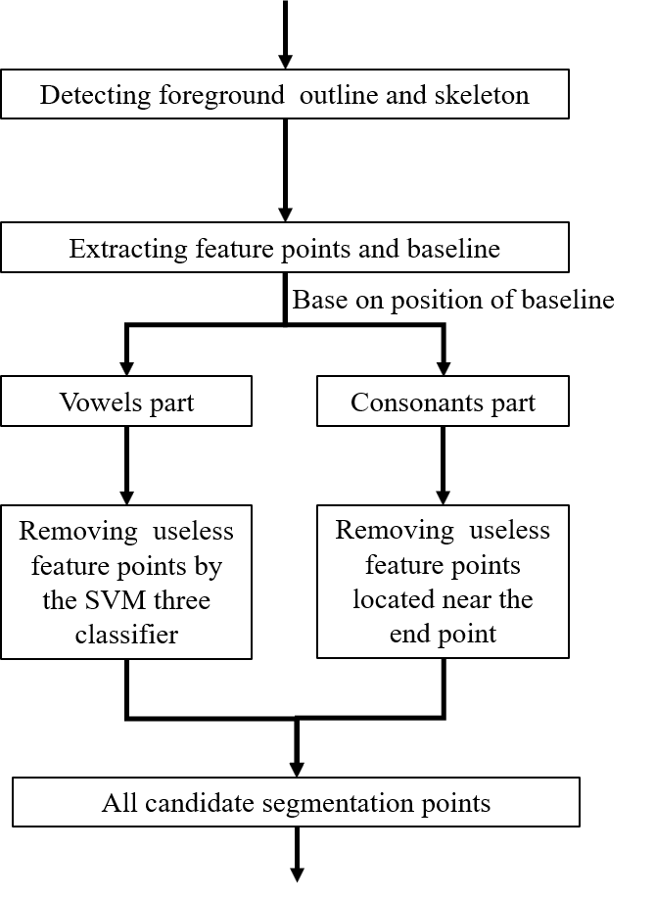
Fig. 6. Flowchart of our algorithm.
- Experiments
To get better segmentation result, the touching pattern in the touching character string should be recognized at first. We extract the connected components by 8-connected regions for each image, and we delete components which width and height less than SW*2. Fig. 7 shows the details and candidate segment points by our algorithm. We can see that our feature points do not appear in pairs. We have chosen two ways to build segmentation paths. When two feature points are located on either side of the stroke, we connect the two feature points to form a segmentation path. In other cases, we cut the strokes directly to form a segmentation path.
 | 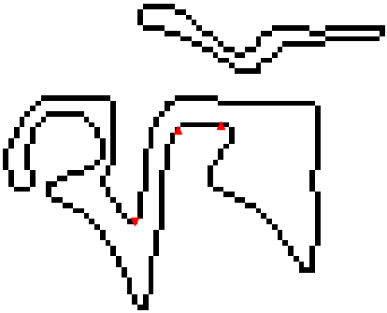
(a) | (b)
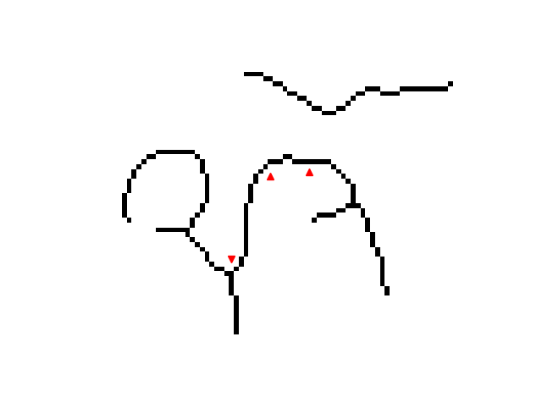 | 
c) | (d)

Fig. 7. Example of (a) original touching character string, (b) foreground outline and feature points, (c) foreground skeleton and feature points, (d) segmentation path
We evaluate the performance of the algorithm based on the distance (d) between a touching point and a candidate point. When d is less than a threshold $d_{th}$, we think that the candidate point is a correct segmentation point. In our paper, we set $d_{th}$ equal to 1.4*SW. We also calculate the recall rate R and the precision rate P [2] to evaluate our algorithm, as following.
$R =\frac{the number of correct separating points}{the number of total truth touching points}×100\%$ (5)
$P =\frac{the number of correct separating points}{the number of total candiate spatating points}×100\%$ (6)
Table 3 reports the performance of the foreground-based combined algorithm on the proposed database. In our algorithm, we extracted the Tibetan baseline with an accuracy rate of 95%. Since we forcibly split vowels and consonants, the actual segmentation result is better than the calculated value. Over-segmentation algorithm can achieve better segmentation results, but too many candidate points will bring expensive calculations. Table 4 reports the average number of candidate points generated by our algorithm and the time to process each file in Python.
Table 3. Performance of the foreground-based combined algorithm on the database.
Database | R (%) | P (%)
TH-TCS-T | 87.54 | 27.56
TH-TCS-M | 80.78 | 32.98
Average | 86.60 | 30.25
Table 4. The average number of candidate points and time to process each file.
Database | Average number | Time for each file (s)
TH-TCS-T | 3.22 | 0.0905
TH-TCS-M | 5.21 | 0.1286
Average | 3.60 | 0.0978

Fig. 8 shows an example of an image segmented by our algorithm and its corresponding segmentation graph. Three paths (Sp₀, Sp₁ and Sp₂) and four components (C₀, C₁, C₂ and C₃) be generated in the end. According to Tibetan character characteristics, we assume that a Tibetan character can be composed of three components at most. The touching character string can produce ten combinations. We need use the classifier to score ten sub-images and find the largest score path in the graph to represent the final segmentation and recognition results.

Fig. 8. Example of a segmentation graph. Segment candidate paths SP₀, SP₁ and SP₂ are generated by algorithm. C₀, C₁, C₂, and C₃ represent different components, respectively. In this segmentation graph, the classifier must be invoked ten times in order to produce a score for each sub-image.
- Conclusion and Future Works
In this paper, we introduce the database about how to obtain dataset and the relevant annotates. The database we have established can be used to evaluate segmentation algorithms for Touching Tibetan character string. We have implemented an algorithm in the database and analyzed the experimental results. In the feature, we hope to further expand our database. Meanwhile, we will use other segmentation algorithms to evaluate our database.

References
- Casey R G, Lecolinet E. A Survey of Methods and Strategies in Character Segmentation[J]. IEEE Trans Pattern Analysis & Machine Intelligence, 1996, 18(7):690-706.
- Oliveira L S, Britto A S, Sabourin R. A Synthetic Database to Assess Segmentation Algorithms[C]// Eighth International Conference on Document Analysis and Recognition. IEEE Computer Society, 2005:207-211.
- Xu L, Yin F, Wang Q F, et al. A Touching Character Database from Chinese Handwriting for Assessing Segmentation Algorithms[C]// International Conference on Frontiers in Handwriting Recognition. IEEE Computer Society, 2012:89-94.
- Liu C L, Koga M, Fujisawa H. Lexicon-driven handwritten character string recognition for Japanese address reading[C]// International Conference on Document Analysis and Recognition, 2001. Proceedings. IEEE, 2001:877-881.
- Li Y, Ma L, Duan L, et al. A Text-Line Segmentation Method for Historical Tibetan Documents Based on Baseline Detection[C]// CCF Chinese Conference on Computer Vision. Springer, Singapore, 2017:356-367.
- Rehman A, Mohamad D, Sulong G. Implicit vs explicit based script segmentation and recognition : a performance comparison on benchmark database[J]. International Journal of Open Problems in Computer Science & Mathematics, 2009(3).
- Chitrakala S, Mandipati S, Raj S P, et al. An Efficient Character Segmentation Based on VNP Algorithm[J]. Research Journal of Applied Sciences Engineering & Technology, 2012, 4(24):5438-5442.
- Congedo G, Dimauro G, Impedovo S, et al. Segmentation of numeric strings[C]// International Conference on Document Analysis and Recognition. IEEE Computer Society, 1995:1038.
- Pal, U., Belaid, A., & Choisy, C. (2003). Touching numeral segmentation using wat-er reservoir concept. Pattern Recognition Letters, 24(1), 261-272.
- Jayarathna U K S, Bandara G E M D C. A Junction Based Segmentation Algorithm for Offline Handwritten Connected Character Segmentation[C]// International Conference on Computational Inteligence for Modelling Control and Automation and International Conference on Intelligent Agents Web Technologies and International Commerce. IEEE Computer Society, 2006:147.
- Xu L, Yin F, Liu C L. Touching Character Splitting of Chinese Handwriting Using Contour Analysis and DTW[C]// Pattern Recognition. IEEE, 2010:1-5.
- Lu Z, Chi Z, Siu W, et al. A background-thinning-based approach for separating and recognizing connected handwritten digit strings[J]. Pattern Recognition, 1999, 32(6): 921-933
- Cheung A, Bennamoun M, Bergmann N W. An Arabic optical character recognition system using recognition-based segmentation[J]. Pattern Recognition, 2001, 34(2):215-233.
- Shi J, Tomasi. Good features to track[C]// Computer Vision and Pattern Recognition, 1994. Proceedings CVPR '94. 1994 IEEE Computer Society Conference on. IEEE, 2002:593-600.
- Chen J, Takagi N. Gray-Scale Morphology Based Image Segmentation and Character Extraction Using SVM[C]// IEEE, International Symposium on Multiple-Valued Logic. IEEE, 2016:177-182.

